5K Run/Walk
March5, 2016
Perry County Park

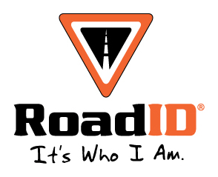

Registration Information
Early (by 2/15/16) $15
Late (after 2/16/16) $20
Race Day (3/5/16) $20

Mail or Drop off Entry Forms to:
Center for Excellence in Rural Health
ATTN: YasmanOlinger
750 Morton Boulevard
Hazard, KY 41701

Location
Perry County Park

Race Day Itinerary
8:45-9:15 Registration
9:30am 5K Race Begins
10:45am Awards

Male & Female
14 & under, 15-20, 21-25, 26-29, 30-39, 40-49, 50-59, 60-69, 70 & over

For more information contact Courtney Brock at clbr227@uky.edu or 606-224-3732

Checks Made Out to:
UK DPT Class of 2017

T-shirt guaranteed with early registration ONLY!!Race held rain or shine!

Name: Phone:

Address:

Age on Event Date: Sex: M or F

Shirt Size: S M L XL Email:

**all proceeds go to the UK Physical Therapy class of 2017

In consideration of the foregoing, I myself, my heirs, executors, administrators, personal representatives, successors, and assigns, waive and release any and all rights, claims, and courses of action I have or may have against the event, its primary sponsors, and its affiliates, their agents, employees, officers, directors, sponsors, their representatives and successors, that may arise as a result of my participation in this event and any pre-and post-race activities. As a parent/guardian I understand that I am responsible for knowing the UIL eligibility rules for any youth under my guardianship and take full responsibility for the entrant pertaining to said rules. I attest and verify that I have sufficiently trained for this event. Further, I hereby grant full permission to any and all foregoing to use my photos, motion pictures, recordings, or any other record of this even for any legitimate purpose, including commercial advertising.

Signature: Date

